IE221 – Probability

Teamwork 5

Zeynep Seçgin

Sadenur Toker

Hilal Avcı

Sultan Dilara Bilgili

Distribution Comparison and Limits of the Theorems

1. Introduction
The purpose of Teamwork 3 (TW3) is to experimentally investigate the validity and limitations of two fundamental probabilistic results: the Strong Law of Large Numbers (SLLN) and the Central Limit Theorem (CLT). Building on the simulation-based methodology developed in TW1 and TW2, this study applies Monte Carlo experiments to several probability distributions with different tail behaviors and moment properties.
Through numerical simulations, graphical analysis, and comparative interpretation, this project aims to discover under which conditions SLLN and CLT work, and more importantly, under which conditions they fail. Special attention is given to heavy-tailed distributions where theoretical assumptions are violated.

2. Introduction to the Distributions
In this section, the probability density (or mass) functions and theoretical moments of each distribution are presented. These properties are critical for interpreting the simulation results.

2.1 Uniform Distribution (0,1)
- PDF:
[ f(x) = 1, \quad 0 \le x \le 1 ]
- Expected Value:
[ E[X] = \frac{1}{2} ]
- Variance:
[ Var(X) = \frac{1}{12} ]
- Properties: Bounded, symmetric, light-tailed.

2.2 Exponential Distribution (λ = 1)
- PDF:
[ f(x) = e^{-x}, \quad x \ge 0 ]
- Expected Value:
[ E[X] = 1 ]
- Variance:
[ Var(X) = 1 ]
- Properties: Right-skewed, light-tailed.

2.3 Pareto Distribution (α = 3, xₘ = 1)
- PDF:
[ f(x) = \frac{3}{x^4}, \quad x \ge 1 ]
- Expected Value:
[ E[X] = \frac{3}{2} ]
- Variance:
[ Var(X) = \frac{3}{4} ]
- Properties: Heavy-tailed, finite mean and variance.

2.4 Pareto Distribution (α = 1.5, xₘ = 1)
- PDF:
[ f(x) = \frac{1.5}{x^{2.5}}, \quad x \ge 1 ]
- Expected Value:
[ E[X] = 3 ]
- Variance:
[ Var(X) = \infty ]
- Properties: Heavy-tailed, finite mean but infinite variance.

2.5 Cauchy Distribution (x₀ = 0, γ = 1)
- PDF:
[ f(x) = \frac{1}{\pi(1 + x^2)} ]
- Expected Value: Undefined
- Variance: Undefined
- Properties: Symmetric, extremely heavy-tailed.

3. SLLN Results

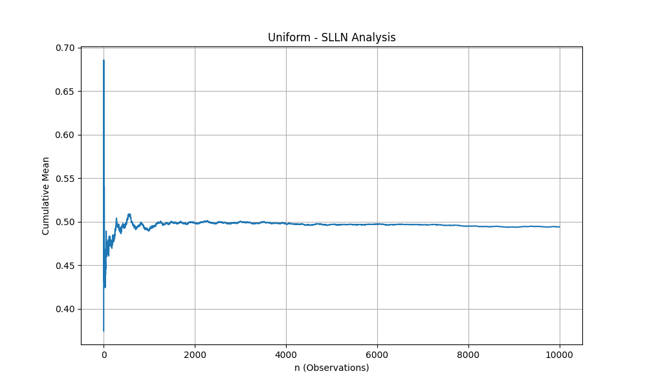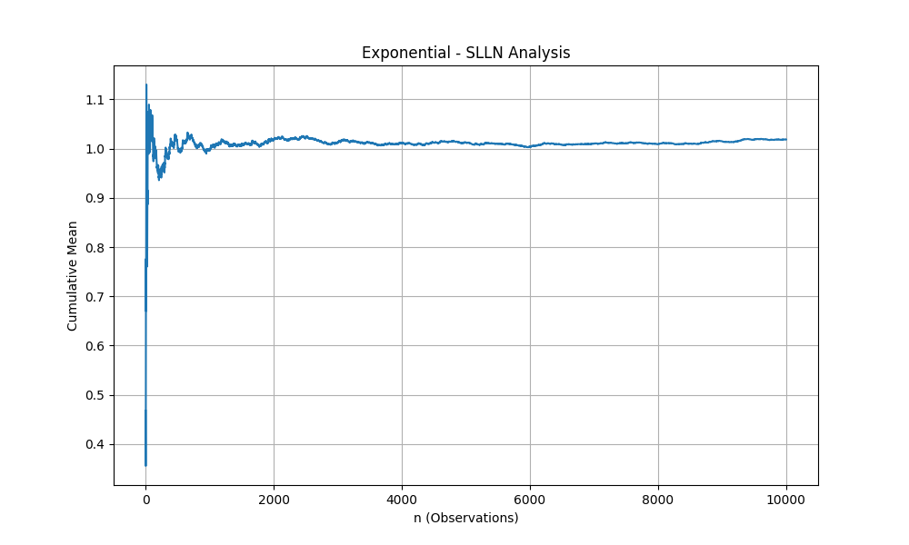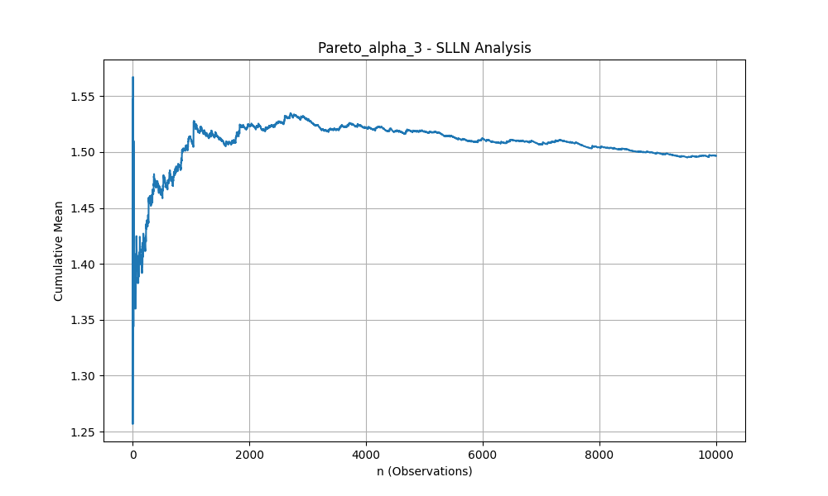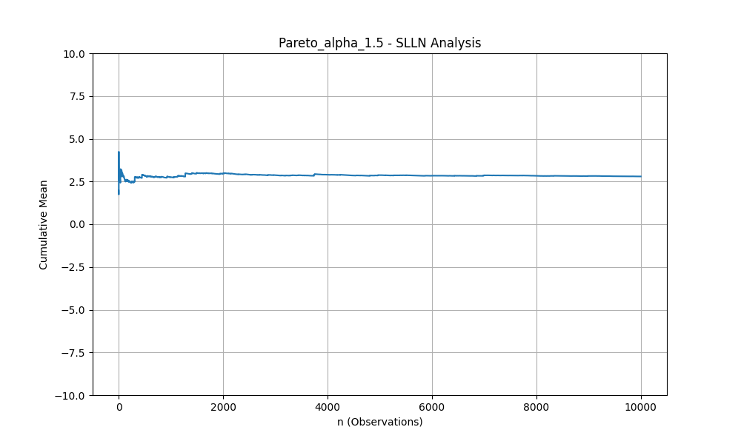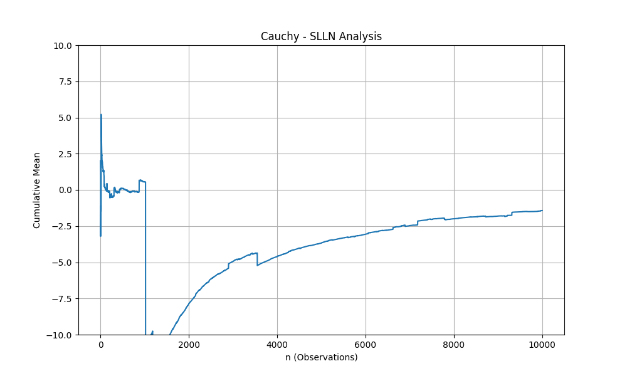
For each distribution, a large sample size (n ≥ 10,000) was generated and the cumulative sample mean was plotted.

The reason for that massive sudden spike seen in the graph is an extreme value from the tail of the distribution, and this value has completely distorted the average.

3.1 Uniform Distribution
The cumulative mean converges rapidly to 0.5. Fluctuations diminish as the sample size increases, clearly confirming the SLLN.

3.2 Exponential Distribution
Although convergence is slower compared to the uniform case due to skewness, the cumulative mean stabilizes around 1, consistent with the SLLN.

3.3 Pareto (α = 3)
Despite heavier tails, the cumulative mean converges to the theoretical mean. However, convergence is noticeably slower and exhibits larger fluctuations.

3.4 Pareto (α = 1.5)
The cumulative mean does not stabilize and displays persistent large jumps. This behavior reflects the infinite variance of the distribution.

3.5 Cauchy Distribution
No convergence is observed. The cumulative mean continues to oscillate wildly even for very large sample sizes. This is expected since the mean does not exist.

4. CLT Results
For the CLT analysis, standardized sums were generated for different sample sizes (n = 2, 5, 10, 30, 50, 100) with 1000 replications.

4.1 Uniform Distribution
Histograms and Q–Q plots show rapid convergence to the normal distribution. Even for moderate sample sizes, the CLT holds well. 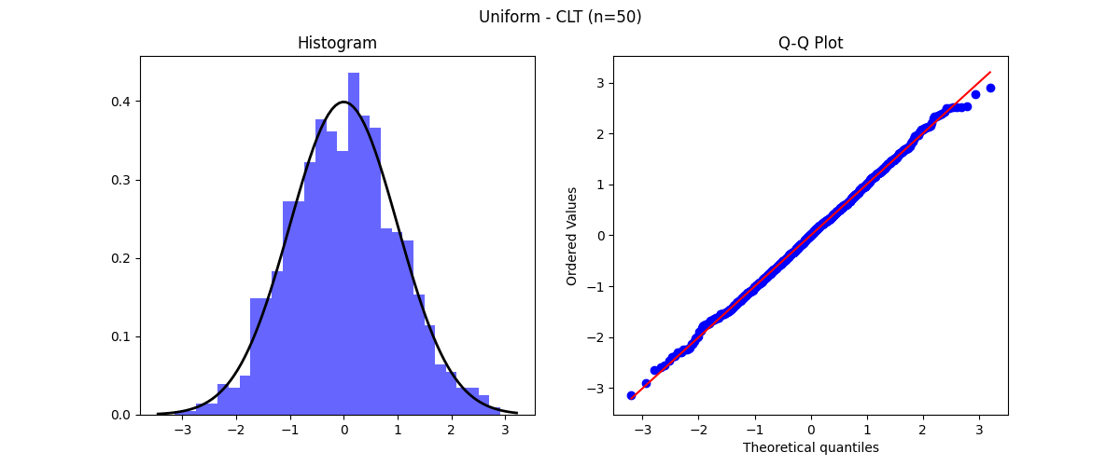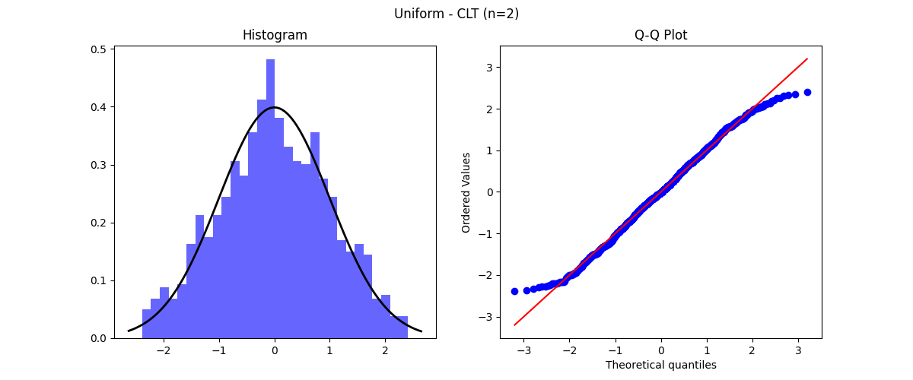
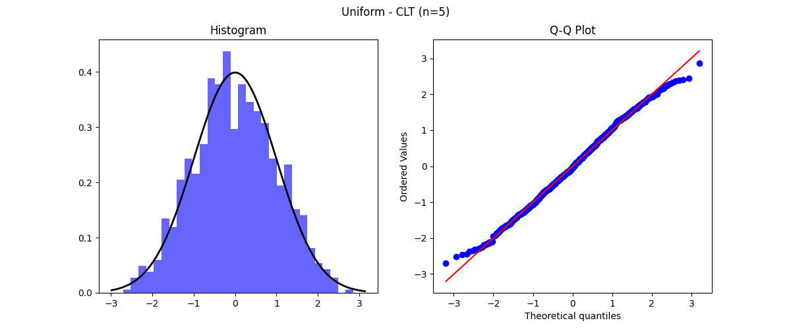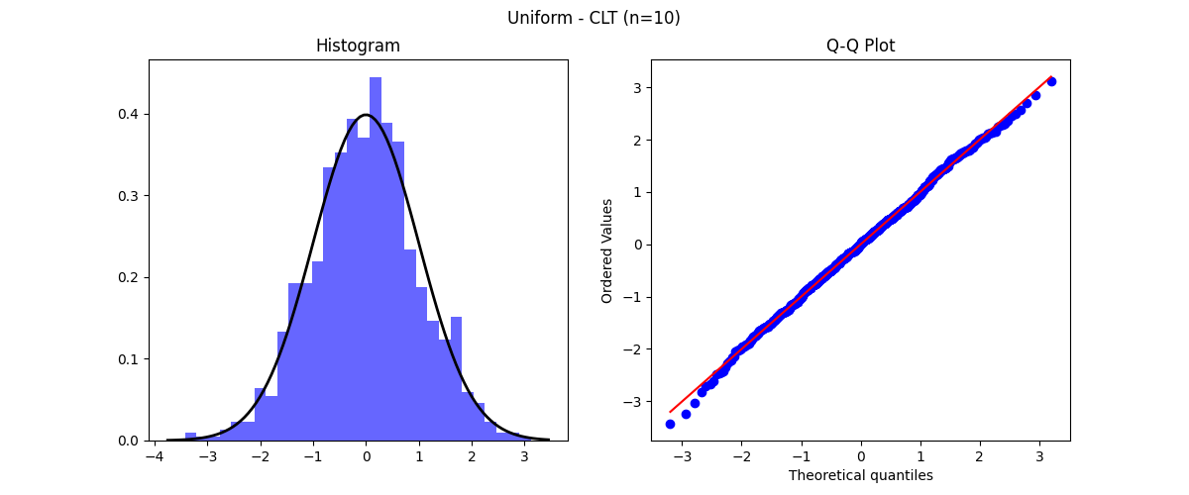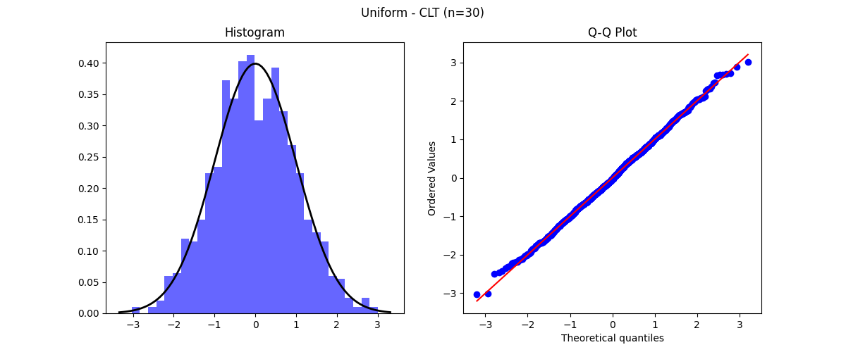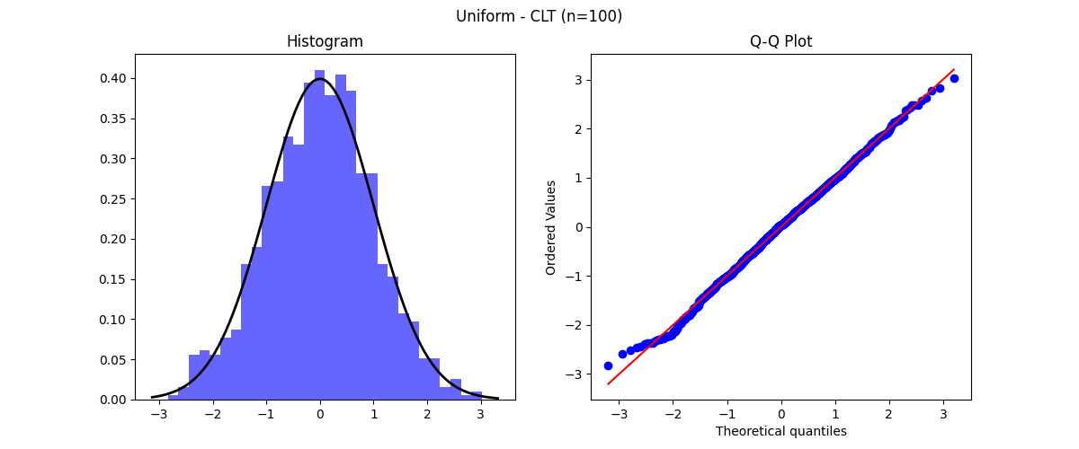

4.2 Exponential Distribution
Convergence to normality is slower due to skewness, but becomes evident as n increases, fully supporting the CLT.

4.3 Pareto (α = 3)
Normality emerges for larger sample sizes, though convergence is slow. Heavy tails delay the CLT effect.
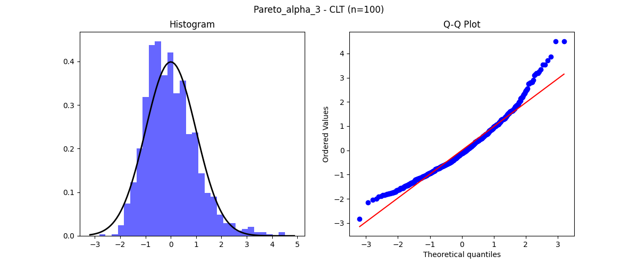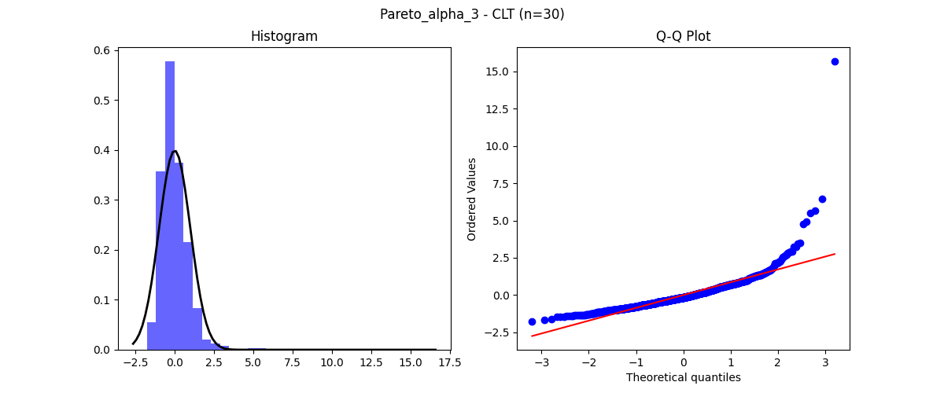

4.4 Pareto (α = 1.5)
The standardized sums do not resemble a normal distribution. The CLT fails due to infinite variance.
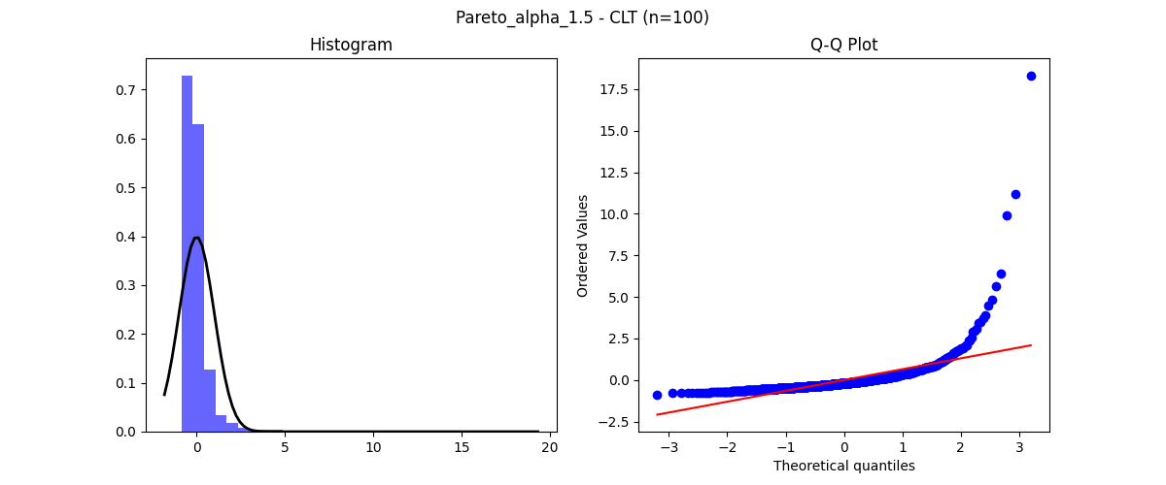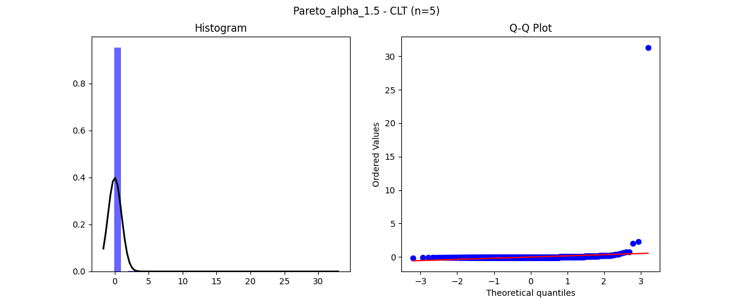

4.5 Cauchy Distribution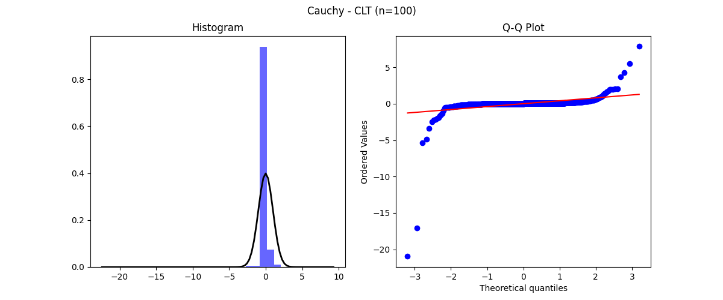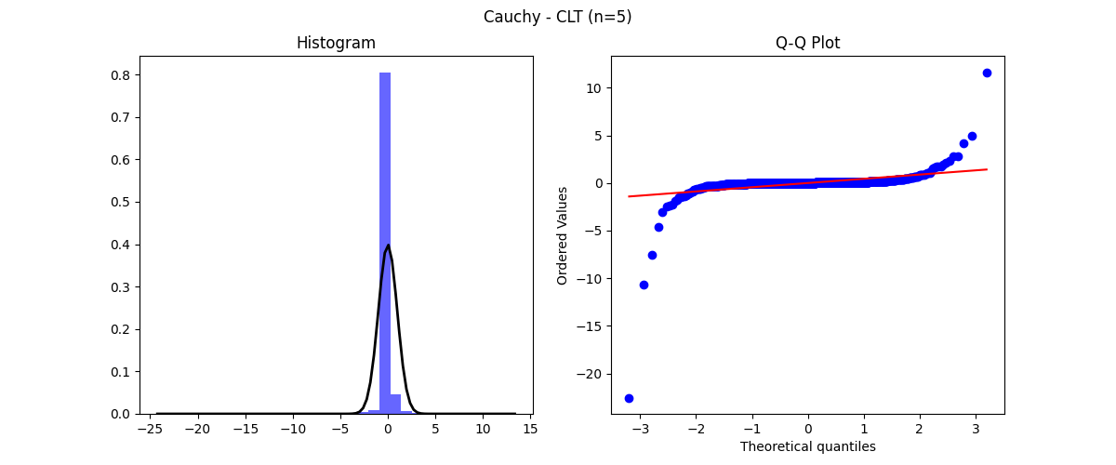
No convergence to normality is observed for any sample size. The CLT completely fails.

5. Comparative Analysis
- SLLN works for Uniform, Exponential, and Pareto (α = 3).
- SLLN behaves abnormally for Pareto (α = 1.5) and fails for Cauchy.
- CLT works for distributions with finite variance.
- SLLN works but CLT does not: Pareto (α = 1.5), since the mean exists but variance is infinite.
- Neither theorem works: Cauchy distribution.
- Heavy-tailed distributions exhibit slower convergence and larger fluctuations.

6. Assumptions of the Theorems
- SLLN requires the existence of the expected value.
- CLT requires finite variance.
Uniform, Exponential, and Pareto (α = 3) satisfy both assumptions. Pareto (α = 1.5) violates the finite variance assumption, while the Cauchy distribution violates both assumptions.

7. Conclusion
This study demonstrates that while SLLN and CLT are powerful results, their validity depends critically on underlying assumptions. Heavy-tailed distributions highlight the practical limits of these theorems and emphasize the importance of understanding distributional properties before applying asymptotic results.

Appendix
import numpy as np
import matplotlib.pyplot as plt
import scipy.stats as stats
import os

# Create directories to save results
if not os.path.exists("results"):
os.makedirs("results")

# 1. PARAMETERS AND DISTRIBUTION FUNCTIONS
# Setting the seed for reproducibility
np.random.seed(42)

def generate_data(dist_name, n):
"""
Generates random samples for the specified distribution.
"""
if dist_name == "Uniform":
# Uniform(0,1)
return np.random.uniform(0, 1, n)
elif dist_name == "Exponential":
# Exponential (lambda=1)
return np.random.exponential(scale=1.0, size=n)
elif dist_name == "Pareto_alpha_3":
# Pareto (alpha=3, xm=1)
return (np.random.pareto(a=3.0, size=n) + 1) * 1
elif dist_name == "Pareto_alpha_1.5":
# Pareto (alpha=1.5, xm=1)
return (np.random.pareto(a=1.5, size=n) + 1) * 1
elif dist_name == "Cauchy":
# Standard Cauchy
return np.random.standard_cauchy(n)

distributions = ["Uniform", "Exponential", "Pareto_alpha_3", "Pareto_alpha_1.5", "Cauchy"]

# 2. SLLN ANALYSIS FUNCTION
def analyze_slln(distributions):
n_slln = 10000 # Number of observations as per requirements

# Create directory for SLLN results
save_path = "results/SLLN"
if not os.path.exists(save_path):
os.makedirs(save_path)

print("Generating SLLN Charts...")
for dist in distributions:
plt.figure(figsize=(10, 6))
data = generate_data(dist, n_slln)

# Calculate Cumulative Mean
cumulative_means = np.cumsum(data) / np.arange(1, n_slln + 1)

plt.plot(cumulative_means)
plt.title(f"{dist} - SLLN Analysis")
plt.xlabel("n (Observations)")
plt.ylabel("Cumulative Mean")
plt.grid(True)

# Limit y-axis for heavy-tailed distributions for better readability
if dist in ["Cauchy", "Pareto_alpha_1.5"]:
plt.ylim(-10, 10)

# Save the figure
filename = f"{save_path}/{dist}_SLLN.png"
plt.savefig(filename)
plt.close()
print(f"--> Saved: {filename}")

# 3. CLT ANALYSIS FUNCTION
def analyze_clt(distributions):
n_values = [2, 5, 10, 30, 50, 100] # Sample sizes
m_replications = 1000 # Number of replications

# Create directory for CLT results
save_path = "results/CLT"
if not os.path.exists(save_path):
os.makedirs(save_path)

print("Generating CLT Charts (This may take a moment)...")
for dist in distributions:
# Create a specific folder for each distribution
dist_path = f"{save_path}/{dist}"
if not os.path.exists(dist_path):
os.makedirs(dist_path)

for n in n_values:
sample_means = []
for _ in range(m_replications):
sample = generate_data(dist, n)
sample_means.append(np.mean(sample))

sample_means = np.array(sample_means)

# Standardization (Z-score normalization)
std_dev = np.std(sample_means)
if std_dev == 0:
standardized_means = sample_means - np.mean(sample_means)
else:
standardized_means = (sample_means - np.mean(sample_means)) / std_dev

# Create Plot: Histogram and Q-Q Plot side by side
fig, axes = plt.subplots(1, 2, figsize=(12, 5))
fig.suptitle(f"{dist} - CLT (n={n})")

# Histogram with Normal Curve Overlay
axes[0].hist(standardized_means, bins=30, density=True, alpha=0.6, color='b', label='Simulation')
axes[0].set_title("Histogram")

# Theoretical Normal Distribution Curve
xmin, xmax = axes[0].get_xlim()
x = np.linspace(xmin, xmax, 100)
p = stats.norm.pdf(x, 0, 1)
axes[0].plot(x, p, 'k', linewidth=2, label='Normal PDF')
axes[0].legend()

# Q-Q Plot
stats.probplot(standardized_means, dist="norm", plot=axes[1])
axes[1].set_title("Q-Q Plot")

# Save the figure
filename = f"{dist_path}/{dist}_CLT_n{n}.png"
plt.savefig(filename)
plt.close()
print(f"--> Completed charts for {dist}.")

# EXECUTE ANALYSIS
if __name__ == "__main__":
analyze_slln(distributions)
analyze_clt(distributions)
print("\nALL PROCESSES COMPLETED! Please check the 'results' folder.")

